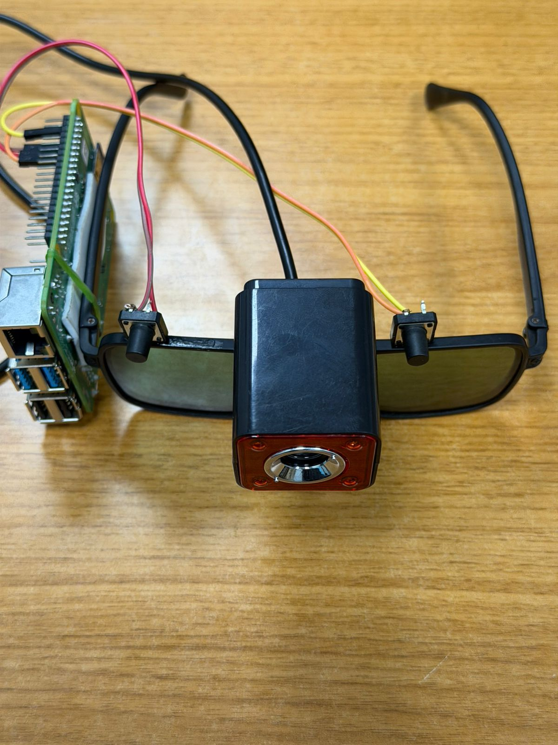
- An Intelligent Mobility and Safety Assistance System for Visually Impaired Individuals

Summery: This project develops an AI-powered smart glass prototype for visually impaired individuals using a Raspberry Pi 4B and advanced computer vision. The system replaces traditional sensors with a YOLOv8-based real-time object detection model and an integrated Pi Camera to identify obstacles like vehicles and pedestrians with high precision. Beyond navigation, the system incorporates specialized Face Recognition and EasyOCR text-reading capabilities to identify known individuals and read labels aloud via Bluetooth audio. Users can interact hands-free through "Hey Glass" voice commands or manual tactile buttons, ensuring seamless environmental awareness without needing a physical cane. By processing all AI models locally on the edge, this wearable solution provides a reliable, low-latency assistance system that significantly enhances user independence and safety.
Tech Stacks:
• Raspberry Pi 4B (4GB RAM)
• Python
• OpenCV
• TensorFlow
• Ultralytics (YOLOv8 Nano)
• EasyOCR(Text-to-Speech)
• Pyttsx3, SpeechRecognition(Voice commands“Hey Glass”)

- Maternal Health Tracker

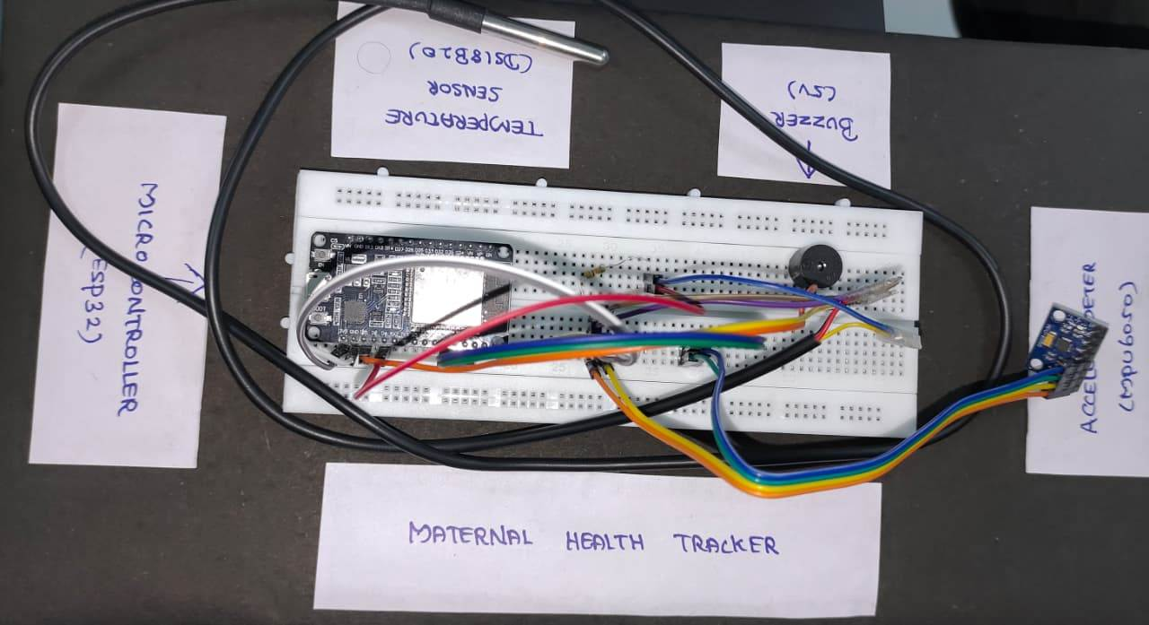
z

Summary: This project proposes an IoT-based Maternal Health Tracker designed to monitor vital parameters like Body Temperature and Fall Detection in expectant mothers. Utilizing an ESP32-based wearable band Prototype, the system detects falls using a threshold-based algorithm and triggers emergency alerts. Data is synced via BLE to a React Native mobile app and stored in a MySQL database via a Spring Boot backend, providing a real-time monitoring interface for both patients and doctors to ensure maternal safety.

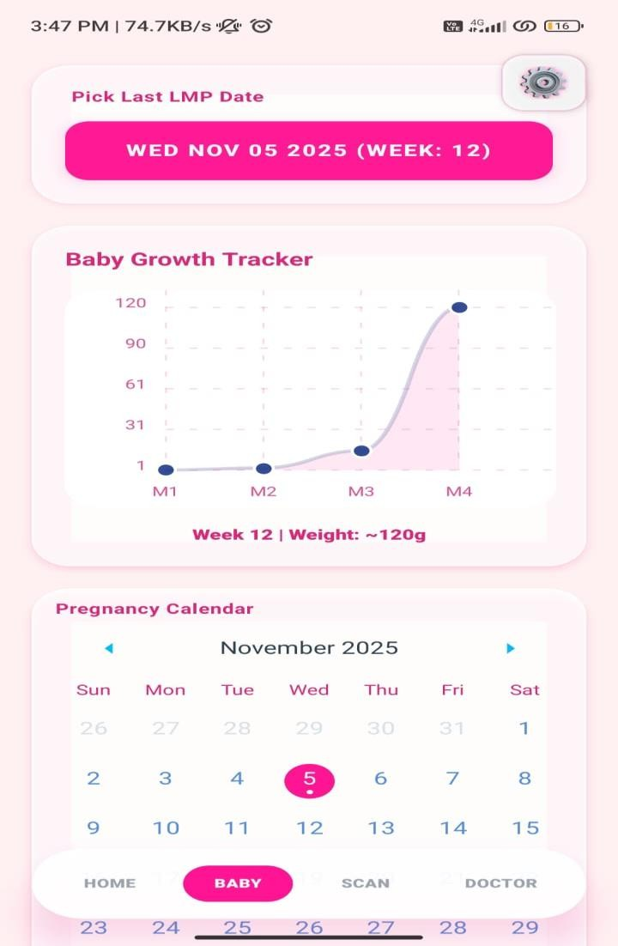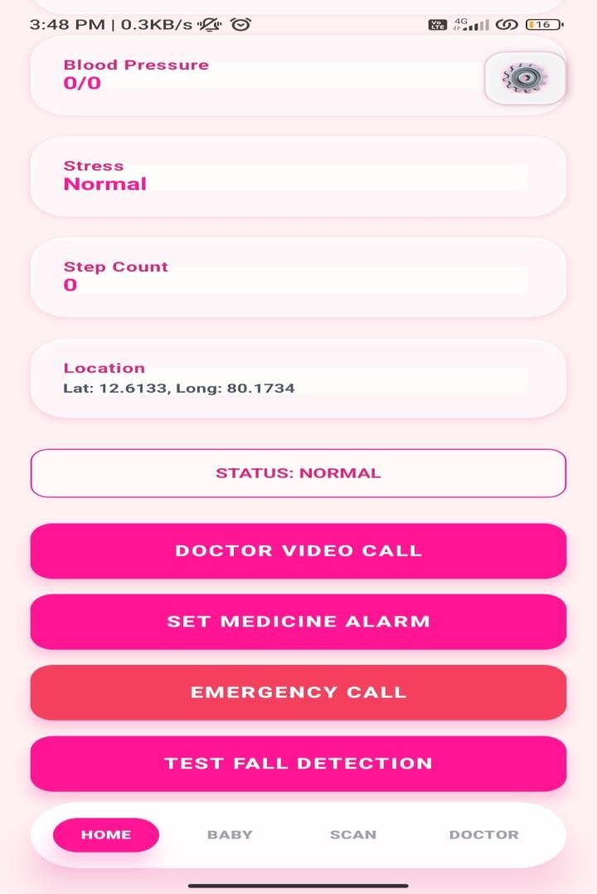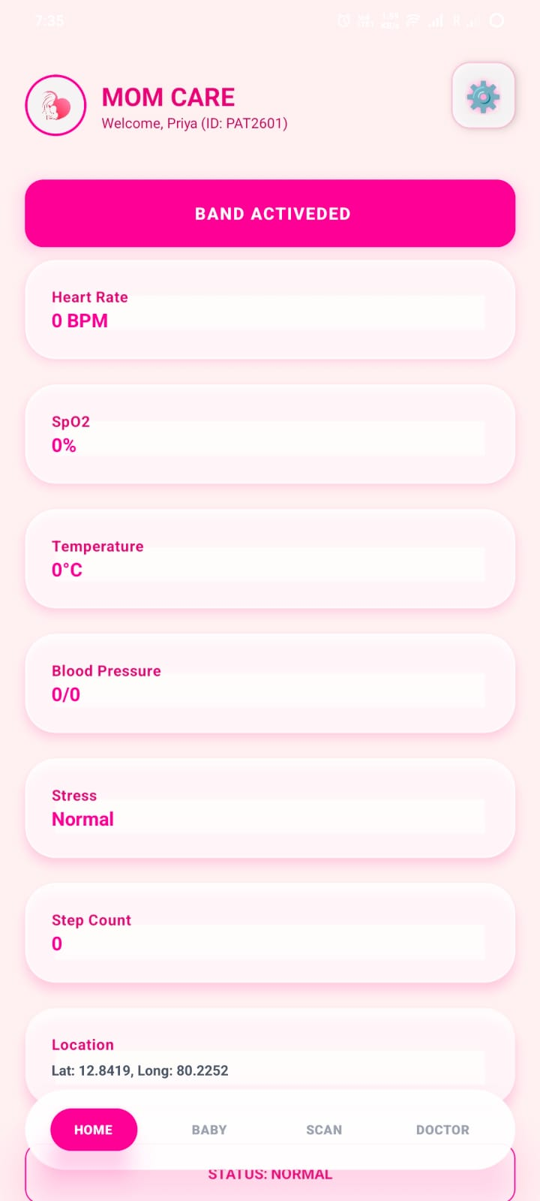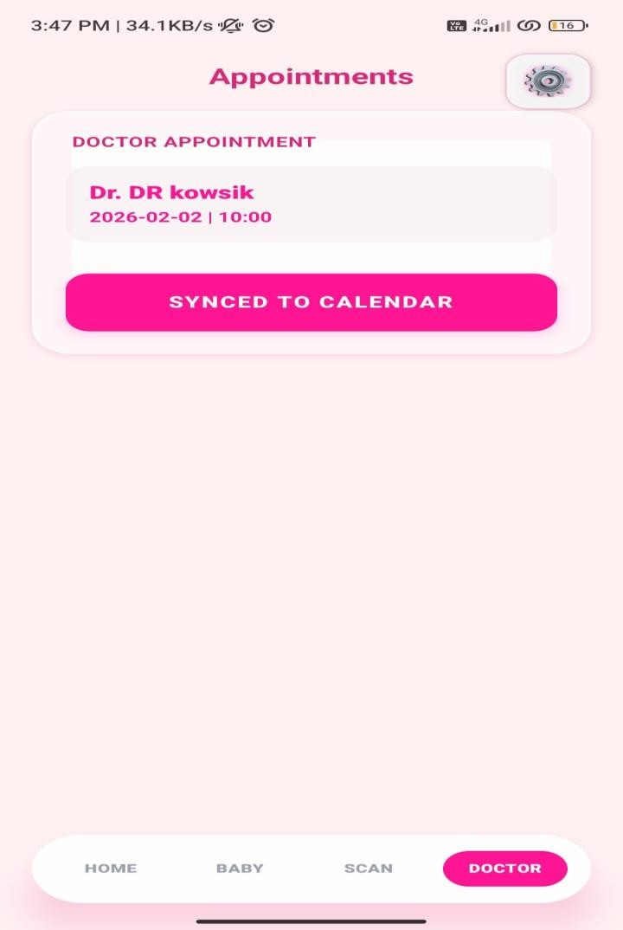
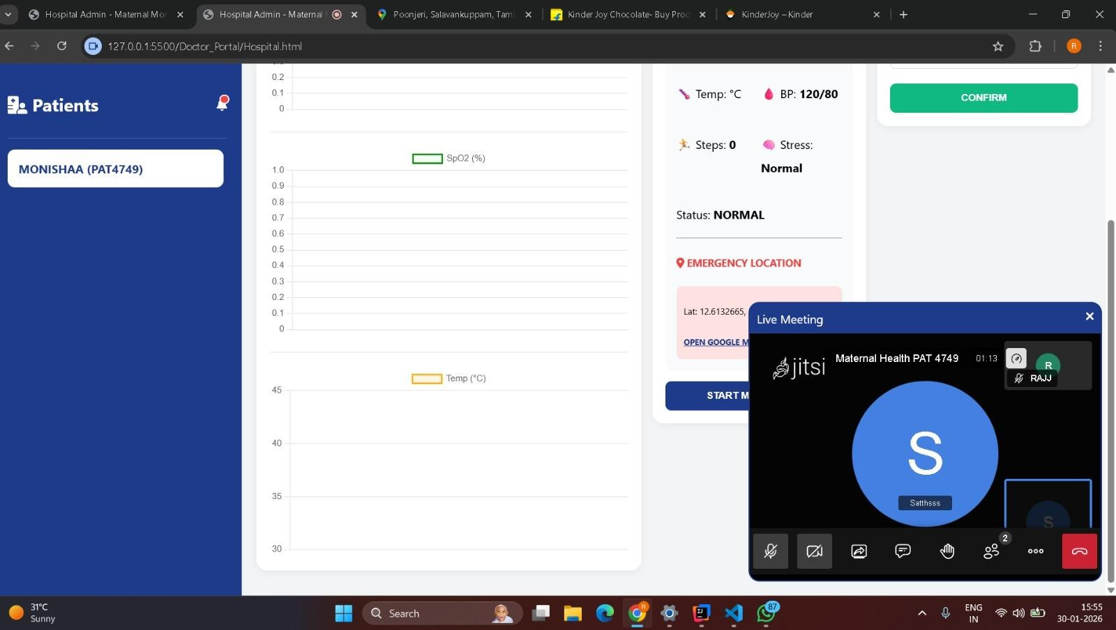

Tech Stacks:
Hardware :
- ESP32 Development Board
- MAX30102 Sensor
- MPU6050 Sensor
- Temperature Sensor
- Li-ion Battery
Software :
- React Native
- Spring Boot
- MySQL Database

3) Smart Plant

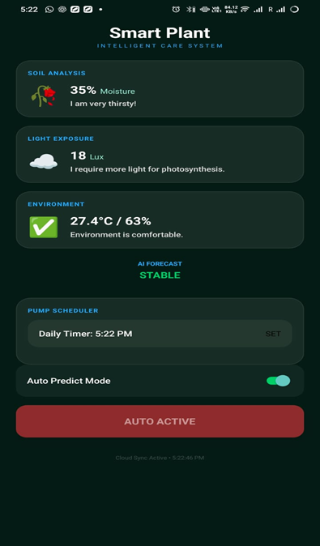

Summary:
This project develops an AI-based smart plant monitoring system using Raspberry Pi and ESP32 to track soil moisture, temperature, humidity, and light intensity in real time.The collected sensor data is analyzed using a Linear Regression AI model to predict the future health condition of the plant.A MERN stack dashboard and mobile interface help users monitor plant status and control the irrigation system remotely.The system also provides voice feedback, instant alerts, and automatic water pump activation to prevent plants from drying out and improve healthy growth.

Tech Stacks :
Hardware :
• Microcontroller : ESP32
• Processing Unit : Raspberry Pi 4
• Soil Moisture Sensor
• Temperature & Humidity Sensor (DHT11/DHT22)
• Light Sensor (LDR / BH1750)
• Relay Module
• Water Pump
• Speaker / Buzzer

Software :
• Python (for data preprocessing, model training, and prediction)
• TensorFlow / Keras (for LINEAR REGRESSION model)
• FastAPI (for backend API)
• React JS / React Native (for dashboard or mobile app)
• Database : Firebase and SQLite

